**Final Group Project Design Document v.01**

**[Name To Be Confirmed]**

**Introduction**

Our brief is to use the theme “light vs darkness” and to create a game that induces psychological flow. All design decisions must be made in line with these constraints.

**Objective of the Game**

As the protagonist you must traverse a dark/foggy environment with only a light source to guide your way to ward of enemies and solve puzzles. The game is an Action-Adventure game. [Luban, P : 2002].

The narrative follows the theme of dark vs light, with the player experiencing two worlds.

The normal world is where two siblings are in the hospital, one is sick and in need of a kidney transplant and the other is preparing to be a living donor. Jelle, the living donor, is trying to keep Ember, the sick one, calm before they go into surgery. She is absolutely terrified something bad will happen, so to explain what will happen and keep her calm Jelle tells her a story/plays a game with her…

The game world is an Aztec labarinth in which Jelle is an Preist who has been chosen to host the Fire Ceremony and prevent the apocylipse and ring about the renewal of the world. However Ember (the Fire God) doesn’t believe the Jelle is the chosen one. Jelle chases her down but can he convince her is is the chosen one?

**Elevator Pitch:** Action adventure game in which you protect your Light in order to save the world.

**Gameplay Description**

In this game, the player is an Preist who is guarding the sacrificial Light from going out so that he can take it to the Fire God and prevent the apocylipse. The game is going to be about resource management of the Light the player carries, this Light takes the place of their health as well as a usable resource. As the player traverses the dark environment their Light will diminish, and the Light is used to complete puzzles, open doors and to light the way.

**Player Character**

Jelle/Preist: Is a teenager determined to save and protect his sick sister.

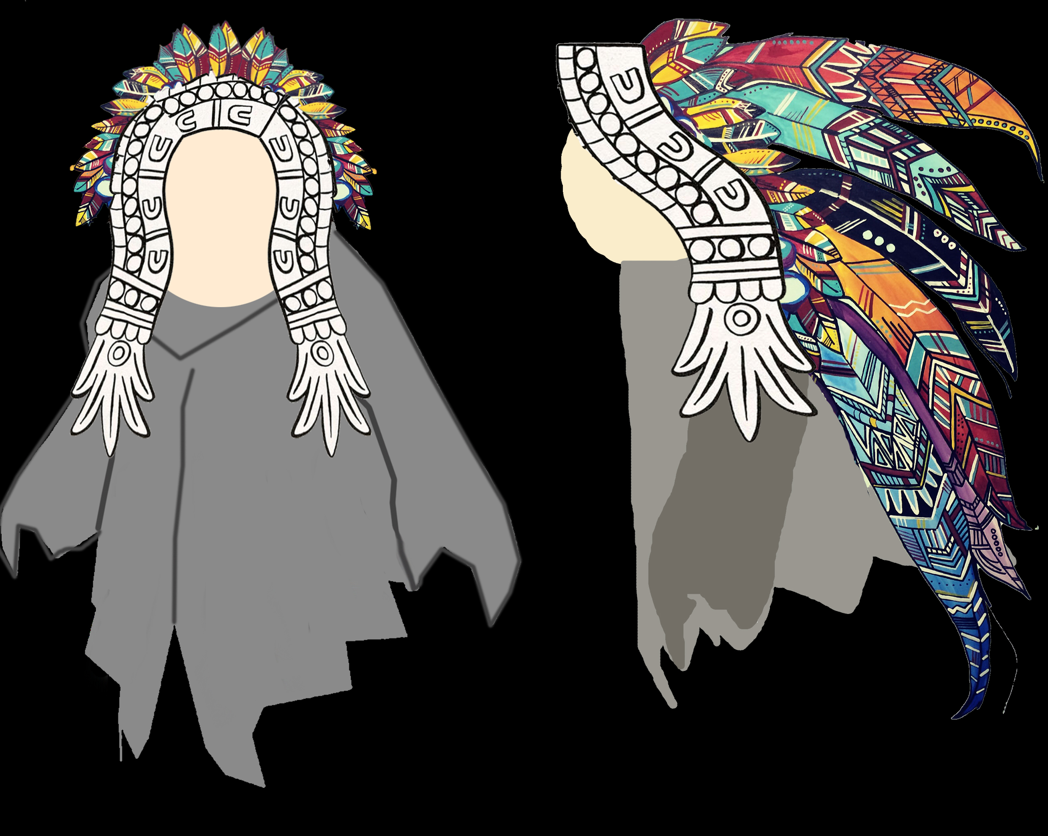

Circular shapes to promote empathy and a “cute” feeling. Has a headband and feathers instead of hair that will change colours over the course of the game to indicate emotional changes in the character arc, and potentially danger. The cloak will be the light source, to create the symbolism that the Preist is the sacrifice.

**Player Controls**

Currently the controls are:

WASD to move.

LMB to rotate mirrors on the y axis.

RMB to rotate mirrors on the x axis.

MMB to rotate the camera around the character.

Mouse Scroll to zoom the camera in and out.

**Game World**

The world of this game is inspired by Aztec architecture and mythology, drawing on the theme and symbolism of sacrifice. However this will be mixed with a cute caricature style to keep the feeling of cute and humour. There will also be implications of home and hospitals to keep the two world blended together.

The world will consist of corridors and larger rooms where puzzles will be.

**Technological requirements**

* Everything will be scripted by Lewis/Heather.
* The software will be Unity Game Engine, Blender/3DS Max 3D modelling software and Photoshop.

**Cutscenes**

Cutscenes will be still images produced in a comic book style during menus, loading screens and respawn screens.

**Game Flow Chart**

The game will start with a main menu/title screen.

There will be an options screen where players can customise controls etc.

If play is pressed, there will be a loading screen.

Then there will be the gameplay screen.

If a player dies, show the respawn screen.

If the player presses pause, a pause screen will show with “exit” “restart” and “options”.

**Game Cameras**

* **Player Camera:** Using a dynamic 3rd person camera. The camera can be rotated and zoomed in and out by the player, but will dynamically move to show things of interest.

**HUD system**

The information on the HUD will be@

* Context sensitive prompts when a player gets near something they can interact with.
* Health/Light bar. This will also be diagetic, with the light in the game reducing brightness as the resource diminishes.
* Target reticule in the centre of the screen.
* Inventory that can be opened/closed.

**Player Character**

**Player Metrics**

**Player Skills**

**Player Inventory**

**Tools**

**Screen**

**Combat**

**Weapon Progression**

**Power Ups**

**Health**

**Health**

Light serves as health bar and resource.

**Alternate States**

Stunned

**Checkpoints**

**Death**

**Rewards And Economy**

* Spatial rewards to avoid obstacles with new areas and spaces to explore/puzzles to solve
* Accomplishment/mastery of mechanics.
* Penalties in the form of restart section on death (frequent checkpoints).
* False rewards to act as a tool for learning the game. Doesn’t offer any spatial progression and is seen as a false reward. The reward comes through learning the games interaction system. [Gazzard, A : 2011]
* Collectables

**Major Characters in Story**

**Game Progression outline**

**Mechanics**

* Walking
* Light source that diminished over time and when preforming an action.
* Collecting refills for Light source. These refills will also be currency to upgrade the character?
* Upgrading the character.
  + Walk speed
  + Climb/jump speed
  + Light radius
  + Light decrease speed reduced
  + Gain more Light from collectables.
* Oils for light source (light source against different enemies)
* Timer for oils to wear off
* Enemies
* Fog for hidden information and atmosphere
* Cranks to open doors over time.
* Levers to open doors immediately.

**Dynamics**

The game will challenge players with a gradual incline in difficulty.

The puzzles discusses so far are:

* Refracting beams of light using mirrors to hit a specific point/create a shape.
  + Mirrors can be rotated on the x or y axis as required.

Each puzzle will adhere to be sure that it: (Einhorn, A : 2015)

* The player understands the objective
* The player discovers the puzzle
* The player works out a solution in their head.

Due to the potential presence of enemies there will be action elements to the adventure game, meaning emphasis must be placed on combat and the enemies themselves. The combat could be achieved in several different ways.

* The player does not directly “attack” enemies, but adds a specific oil to change the colour of their lamp, which then repels the enemies or kills them.
* The player adds oil to make the lamp flare and knock back enemies, does damage within a certain radius. The oils still would be for specific enemies.
* There are inanimate objects in the environment that the player can use as checkpoints and do repel/kill enemies. Otherwise the player must keep their lantern lit and avoid enemies.

Regardless all enemy combat must contain these things [Ruiz, B: 2013]:

* Attack Animation to build anticipation (usually 6 frames).
* Struck Animation which is fast and over the top to sell the pain of the enemy. Flash the struck character a colour to visual show something has happened.
* Weapon swing effects which should be big and flashy, fast and follow a smooth linear line.
* Hit effect must also be big and flashy with quick fire. Similar to explosions.
* Screen shake to sell the impact.
* Animation freeze when a hit connects for a few frames.

Optional combat effects:

* Weapon impact effect.
* Blood.
* Attacker ground dust.

**Game Levels**

|  |  |  |  |  |  |  |  |
| --- | --- | --- | --- | --- | --- | --- | --- |
| Game Name | Level Name/File Name | | | | | |  |
| **Prologue** | **Act 1** | **Act 2** | | | **Act 3** | **Epilogue** |
| **Level 01 – Hospital Bedroom** | **Level 02 – Underground cavern/ruined temple** | **Level 03 – extremely dark ruined fire temple** | **Level 04 –** ruined ice temple | **Level 05 –** slightly distressed jungle/earth temple | | **Level 06 – hospital corridor** |
| **Location** | Hospital | Bottom of Temple (underground) | Floor above bottom of temple(above ground) | Middle floor of temple. | Top floor/surfaces of temple. | | Hospital, on way to anaesthesia |
| **Game Play** | None | Stay in the light, walk/jump/climb, | Stay in the light, walk/jump/climb, puzzle, | Puzzle to defeat Bosses | Carrying Ember, stay in the light. | | None |
| **Objective** | None | Find Ember | Save Ember | Fight with Ember | Save Ember | | None |
| **Story Beat** | Exposition | Jelle chases Ember, and Ember then gives opportunity to prove self via the Trials. | Jelle Meets the Gods of death and begins his trials. | Jelle completes trials and defeat the Gods of Death together. | Ember is mortally wounded after defeating Gods, and Jelle must perform the ritual. | | Ember and Jelle are being taken into surgery, which is a success |
| **New Weapon** | None | Lantern/Light | No | no | No | | None |
| **Enemies/Hazards** | None | Floor Spikes/Darkess | Gremlin (Ember).  Tormentor (Gods of Death). | Time pressure.  Tormentor (Gods of Death). | Time pressure. | | None |
| **Mechanics** | None | Resource management, collecting, | Resource management, collecting, rotate mirrors x | Resource management, collecting, rotate mirrors y | Resource management, collecting, rotate mirrors both ways | | none |
| **NPC** | Jelle & Ember.  Nurse.  Parents. | Ember/Fire God | Ember.  Gods of Death. | Ember.  Gods of Death. | Ember. | | Jelle and Ember, parents, medical staff. |
| **Collectables** | None | Light refills | Light refills. | Light refills. | Light refills. | | None |
| **Time Of Day** | Dusk | Night | Night | Pre-dawn | Dawn. | | Day |
| **Colour Mapping** | Orange/yellow | Blue/gray | Blue/gray | Blue/red | Orange/yellow | | Orange/yellow/red |

**Non Player Characters**

|  |  |  |  |  |  |  |
| --- | --- | --- | --- | --- | --- | --- |
| **Name** | **Age** | **Gender** | **Type** | **Background** | **Level Encountered** | **Interaction** |
| **Ember/Fire God** | Young Child | Female | Mission deliverer, escort/defend and gremlin. | Sick sister of player, becomes sicker and slower as the game progresses. Is running away from your sacrifice. | Each level. | Collision.  Carrying (late game). |
| **God of Death (mom)** | Adult | **Female** | **Tormentor, time pressure.** | Is the mother of both characters, and needs to be convinced Jelle is chosen one. Fears for his safety. | **Level 03/04/05** | **Collision, avoid, trap with light.** |
| **God of Death (dad)** | **Adult** | **Male** | **Tormentor, Time pressure.** | Tells Jelle he must save and protect Ember, its his job as “older brother”/”priest”. | **Level 03/04/05** | **Collision, avoid, trap with light.** |

**Collectables/Object sets**

* **Light refills on every level.**

**Cutscenes**

|  |  |  |
| --- | --- | --- |
| **Cutscene** | **Outline of Cutscene** | **Level** |
|  | **Hospital bedroom, where Jelle and Ember discuss fears and play the game.** | **Prologue** |
|  |  | **Any** |
|  |  | **Any** |
|  |  | **Any** |
|  | **Hospital corridor, where Jelle and Ember are being** | **Epilogue** |

**Music and SFX**

**Music**

* Ambient music.
* Theme music for Jelle
* Theme music of Ember
* Theme music for Bosses.
* Battle music for fight

**SFX**

* Collecting sound
* Walking (player).
* Walking (fire god).
* Sound to indicate player did something right.
* Mirror rotating.
* Fire crackle

**Aesthetics**

**Themes**

* Darkness and Light

**Player Experience**

The game will be a puzzle game primarily, so curiosity and challenge are essential. The puzzles will get gradually more complex, but with little or no punishment or lost progress to keep frustration low.

The game will focus on trying to achieve Flow by focusing on the factors; Challenge VS Skill, Anxiety VS Boredom, Difficulty or Difficulty Balance. In an attempt to balance these elements and keep the player within the Flow Channel, the puzzles should follow a pattern such as outlined below.

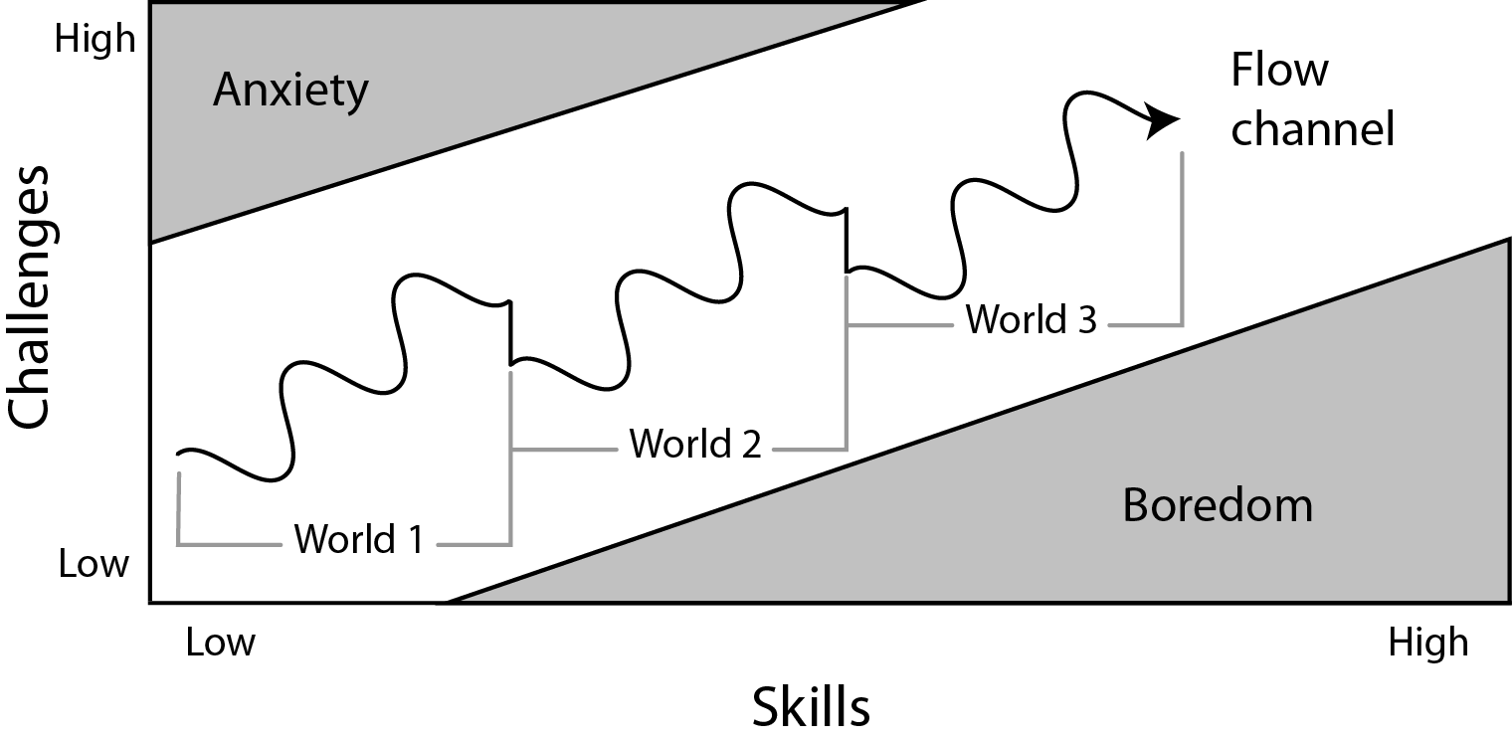

In the above diagram the player is increasing skill and challenge in a wave pattern, with dips in difficulty at the start of each new puzzle, section, world, mechanic etc. The intention of creating game play following this diagram is that there is variation in the gameplay between the difficulty, not just between sections but within each section. [Sala, T: 2013]

There will be visual incremental progress, to show the player they are getting closer to their destination or not. The puzzles should force players to think about the mechanics in a different way by being offered multiple choices but only a select few (or one) solution. [Kockar, A : 2016]

The player experience is also directly linked to the theme of dark vs light. The player should be aware of and feel this struggle throughout the game.

**Demographics**

Using Bart Stewarts Unified Model [Stewarts, B : 2011] to narrow down our player type.

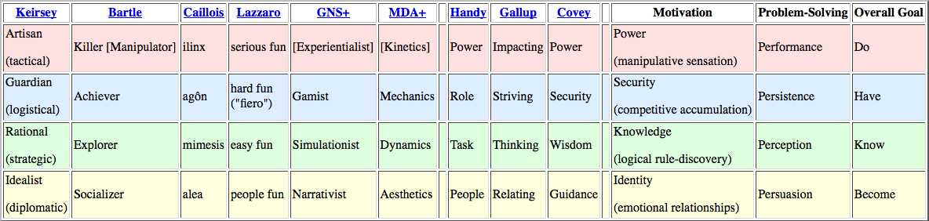

Achiever/Explorer seems to fit with the players of Action Adventure games best. That means our player will be likely to enjoy: action, vertigo, tool-use, vehicle use, horror, gambling, speedruns, exploits as a Killer. As a Explorer the player will enjoy: puzzles, creative building, world-lore, systems analysis, theorizing, surprise.

**Time Required To Play**

**The Rules**

**Artistic Style Outline**

**Game Assets**

**Suggested Game Flow Diagram**

**Narrative**

**Bibliography**

Freeman, T. (1997) *Creating A Great Design Document* [Online] Accessed On [29/02/2016]. Available At: <http://www.gamasutra.com/view/feature/131632/creating_a_great_design_document.php>

Ryan, T. (1999) *The Anatomy of a Design Document, Part 1: Documentation Guidelines for the Game Concept and Proposal* [Online] Accessed On [29/02/16]. Available At: <http://www.gamasutra.com/view/feature/131791/the_anatomy_of_a_design_document_.php?page=3>

Bakker, J. (2009) *A GDD Template for the Indie Developer* [Online] Accessed on [29/02/16] Available at: <http://www.gamasutra.com/blogs/JasonBakker/20090604/84211/A_GDD_Template_for_the_Indie_Developer.php>

**Demographics**

Stewart, B (2011) *Personality and Play Styles: A Unified Model.* [Online] Accessed On: 28/07/17. Available At: <http://www.gamasutra.com/view/feature/134842/personality_and_play_styles_a_.php>

Einhorn, A (2015) *Four Step Puzzle Design* [Online] Accessed On [26/07/17] Available At: <http://www.gamasutra.com/blogs/AsherEinhorn/20150528/244577/Fourstep_puzzle_design.php>

Kockar, A (2016) *On Puzzle Design And Fabric* [Online] Accessed On [26/07/17] Available At: <http://www.gamasutra.com/blogs/AtilKockar/20161026/284098/On_Puzzle_Design_and_Fabric.php>

Luban, P (2002) *Designing and Integrating Puzzles In Action-Adventure Games* [Online] Accessed On (26/07/17) Available At: <http://www.gamasutra.com/view/feature/131326/designing_and_integrating_puzzles_.php>

Sala, T (2013) *Game Design Theory Applied: The Flow Channel* [Online] Accessed On (26/07/17) Available At: <http://www.gamasutra.com/blogs/ToniSala/20131208/206535/Game_Design_Theory_Applied_The_Flow_Channel.php>

<http://www.gamasutra.com/blogs/ToniSala/20140102/207665/Game_Design_Theory_Applied_the_puzzle_of_designing_a_puzzle_game.php>

Kantilaftis, H (2015) *Learning From The Best: Action Adventure Games.* [Online] Viewed On: 28/07/17. Available At: <https://www.nyfa.edu/student-resources/learning-from-the-best-action-adventure-games/>

**Combat System Research**

**Ruiz, B (2013) *Anatomy Of A Successful Attack (2.0)* [Online] Viewed On: 28/07/17. Available At:** [**https://aztez.com/blog/2014/01/06/anatomy-of-a-successful-attack/**](https://aztez.com/blog/2014/01/06/anatomy-of-a-successful-attack/)

**Anonymous (2016) *About Combat System Design* [Online] Viewed On: 28/07/17. Available At:** [**https://breadcrumbsinteractive.com/about-combat-system-design/**](https://breadcrumbsinteractive.com/about-combat-system-design/)

**Anonymous (N.D) *A Huge List Of Common Themes* [Online] Viewed On: 28/07/17. Available At:** [**https://literarydevices.net/a-huge-list-of-common-themes/**](https://literarydevices.net/a-huge-list-of-common-themes/)

**Rewards**

Gazzard, A. (2011) *Unlocking The Gameworld: The Rewards Of Space and Time in Video Games.* [Online] Viewed On 28/07/17. Available At: <http://gamestudies.org/1101/articles/gazzard_alison>

Sala, T (2013) *Game Design Theory Applied: A Layered Rewards System.* [Online] Viewed On 28/07/17. Available At: <http://www.gamasutra.com/blogs/ToniSala/20131215/207064/Game_Design_Theory_Applied_A_Layered_Rewards_System.php>